Put Balls in Basket
Send Feedback

You have been given a task to move balls to a basket. There are many balls lying on the floor scattered and needs to be put in the basket.

The process is fully automatic and you just need to press a button to initiate the process. After pressing the button, the ball automatically gets stacked in the basket.

The addition of a ball starts from the left side of the basket and gets stacked up as a row gets fully filled.

The balls are picked at random by the machine and they have the following colors - 'red', 'blue', 'yellow', 'lightgrey', 'darkorchid', 'black', 'orange', 'deeppink', 'green', 'purple', 'saddlebrown', 'lightseagreen', 'deepskyblue', 'firebrick' and 'crimson'.

The basket is empty as seen below -
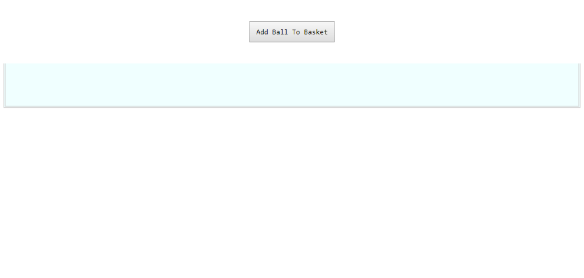

The balls get filled like this -
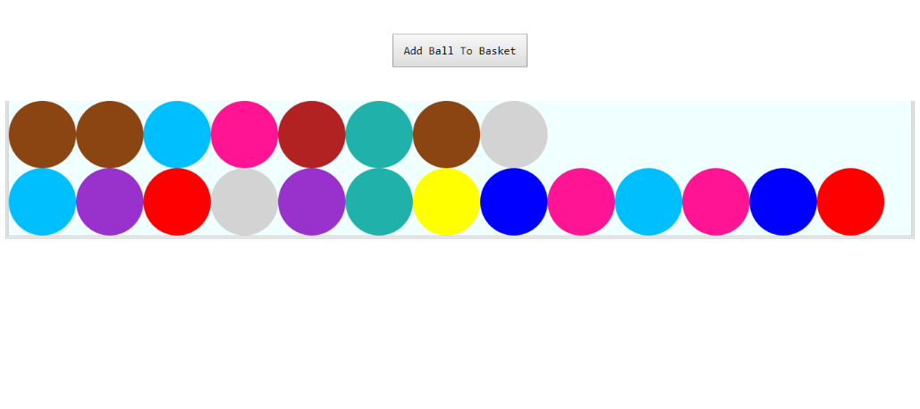

If a row gets filled, the next will stack above like this -
